**DISCLAIMER**

This document is submitted with the explicit understanding that the contents are confidential and would not be divulged to any third party without prior written consent from Dotsquares Ltd. Services are supplied according to our terms and conditions <http://www.dotsquares.com/terms>

a

P

e

g

|

**1**

**0**

**1**



**CONFIDENTIAL**

(

10

.07

.2019)

Project

Estimate

**Cultural Awareness Mobile Application**

**Version 1.0**

This document outlines the general scope of your

project based on our understanding of the

requirements provided and discussions to date.

Lead ID:

66282

Client:

**Ariel F**

**reaner**

|  |  |  |
| --- | --- | --- |
|  | | |
|  | **02** | P a g e | **2** |

# Revision History

|  |  |  |  |  |
| --- | --- | --- | --- | --- |
| **Version** | **Date** | **Description** | **Prepared by** | **Reviewed by** |
| 1.0 | 10/07/2019 | Project Scope | Nikhil | Varun |
|  |  |  |  |  |

|  |  |  |
| --- | --- | --- |
|  | | |
|  | **03** | P a g e | **3** |

**Contents**

**REVISION HISTORY ........................................................................................................................................................ 2**

**PURPOSE OF THE DOCUMENT ....................................................................................................................................... 4**

**PROJECT OBJECTIVE ...................................................................................................................................................... 4**

**SCOPE OF WORK ........................................................................................................................................................... 4**

DELIVERABLES ....................................................................................................................................................................... 4

SYSTEM FEATURES.................................................................................................................................................................. 5

*End User Features ......................................................................................................................................................... 5*

*Admin Panel (Web based):............................................................................................................................................ 9* NOTES ................................................................................................................................................................................. 9

TECHNOLOGY ........................................................................................................................................................................ 9

**ESTIMATE DETAILS ....................................................................................................................................................... 10**

ESTIMATE BREAKDOWN ........................................................................................................................................................ 10

IMPORTANT NOTES .............................................................................................................................................................. 10

*Content Submission .................................................................................................................................................... 10*

*Software & Platform Updates ..................................................................................................................................... 10* PROJECT MANAGEMENT TOOL (DS PROJECTS) .......................................................................................................................... 10

DEPLOYMENT ...................................................................................................................................................................... 11 WARRANTY ......................................................................................................................................................................... 11

INTELLECTUAL PROPERTY RIGHTS ............................................................................................................................................ 11

TESTING ............................................................................................................................................................................. 11

ENVIRONMENT .................................................................................................................................................................... 11

**ADDITIONAL SERVICES ................................................................................................................................................. 12**

SUPPORT ............................................................................................................................................................................ 13

NETWORK SUPPORT ............................................................................................................................................................. 13

DIGITAL MARKETING ............................................................................................................................................................ 13

**WHY DOTSQUARES ...................................................................................................................................................... 14**

WHAT WE DO… ................................................................................................................................................................... 15

AFFILIATIONS ...................................................................................................................................................................... 15

PORTFOLIO ......................................................................................................................................................................... 16

WHAT OUR CLIENTS SAY ........................................................................................................................................................ 16

|  |  |  |
| --- | --- | --- |
|  | | |
|  | **04** | P a g e | **4** |

# Purpose of the Document

This document outlines the general scope of your project based on the requirements provided and discussions to date. The main objective at this stage is to ensure that all parties agree upon the general scope, budget and schedule of the project prior to commencing work on subsequent stages (which can include in-depth planning if needed).

Clients are urged to ensure that all the details contained within this document are clear and fully meet their requirements before any work commences. Timescales mentioned only cover the scope listed, if this changes, costs and timings will change accordingly.

Once you are happy contact us and we will progress into the next stages. This may include further detailing requirements and functionality or it may go straight into design. This will depend on the nature of the project.

# Project Objective

The objective of the project is to create an information based mobile application which will show the information about the communities’ focus groups. People can view the different communities and can select their preferred categories to view further classifications and its content.

# Scope of Work

The scope of work involves a technical delivery of Mobile apps solution providing information about different communities. We will also scope for creating web based admin panel and integrating the web services. Scope involves completing the modules as mentioned in the System Features section.

## Deliverables

|  |  |  |  |  |  |
| --- | --- | --- | --- | --- | --- |
|  | | **Item** | | **User** | **Device/Platform** |
| 1 | | Application Designing | | End - User | Adobe Photoshop |
| 2 | | iPhone Application (source code) | | End – User | iPhone |
| 3 | | Android Application (source code) | | End – User | Android |
| 4 | | Complete backend and web services  (source code) | | Application Admin | Admin Panel |
| 5 | | Database | | - | MySQL, SQLite |
|  | | | | | | | |
|  | | **05** | | P a g e | **5** | | | |

## System Features

### End User Features

It will have below listed features:

1. **Project setup**

We will be going to setup the project in this phase at our development environment.

1. **Splash**

This would be the first screen which will have the logo and background image and displays for few seconds.



1. **Intro screen**

It will show some intro message and further they can proceed with the home screen.

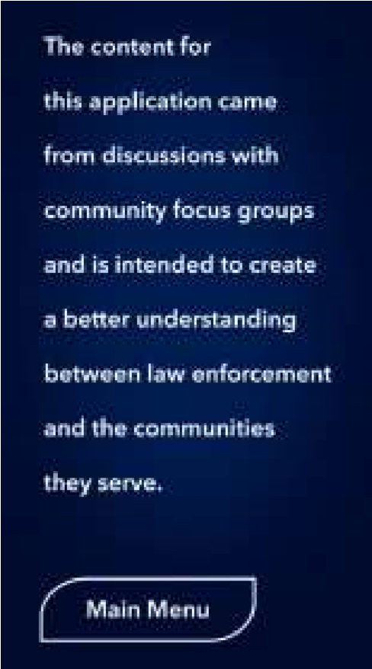

|  |  |  |
| --- | --- | --- |
|  | | |
|  | **06** | P a g e | **6** |

1. **Home screen**

We would be displaying main menu items through which the users can navigate to other screens. Below would be the expected menu items:

* + About the project
  + Communities
  + Contact
  + Intro message

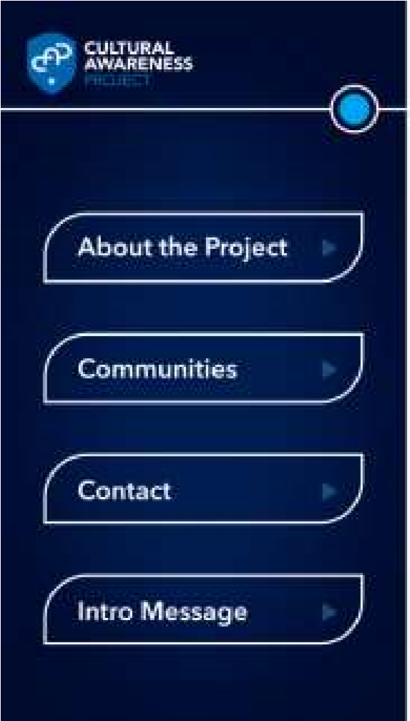

1. **About the project**

It would show the information content about the project along with the logo of the San Diego District Attorney California board.



|  |  |  |
| --- | --- | --- |
|  | | |
|  | **07** | P a g e | **7** |

1. **Communities listing page**

This screen will display list of communities name linked to their detail page.

* + African American youth
  + Mexican and Mexican American
  + Latino youth
  + Asian
  + Vietnamese
  + East African/ Somali
  + East African/ Somali youth
  + Muslim
  + Samoan
  + Karen/ Karenni
  + Chaldean

1. **Communities detail page**

The detail page of the community will show different classification of the selected community based on: 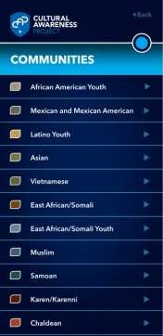

* + Tradition and belief
  + Greetings
  + Visiting households
  + Experience with law enforcement

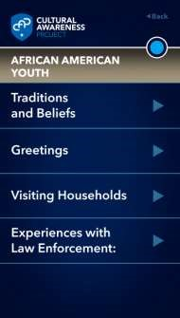

|  |  |  |
| --- | --- | --- |
|  | | |
|  | **08** | P a g e | **8** |

1. **Communities sub-detail page**

When a user clicks over any of the classification then they will be able to view further details of each.



1. **Contact screen**

This screen will show the contact information and a contact form so user can contact the admin.

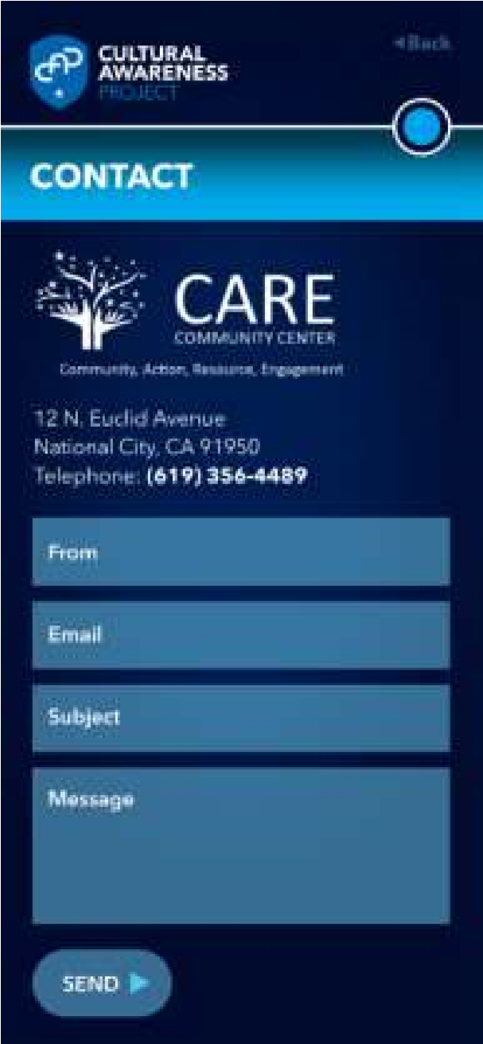

|  |  |  |
| --- | --- | --- |
|  | | |
|  | **09** | P a g e | **9** |

### Admin Panel (Web based):

Admin will be handling this section to manage entire application features and content.

1. **Login**

Admin can login to their secured panel from where they can manage the application users, features and content. Admin will enter their email address/ username and password to login.

1. **Manage communities and sub-community**

The admin will be able to manage the communities from this section. Admin can view/edit, disable and delete the communities. Admin can link the communities

1. **Manage community content**

The admin will be able to manage content of the respective community by selecting their linked subcommunity.

1. **Manage content screens**

Admin will be able to manage the information content screens of the application from the admin panel.

## Notes

* Google play store and apple store developer account to make applications live.
* We expect that content to be added in the application will be provided by the client.

## Technology

|  |  |  |  |  |
| --- | --- | --- | --- | --- |
|  | **Component** | **iPhone** | **Android** | **Backend** |
| 1 | Operating system | Apple iOS | Google Android | Linux |
| 2 | Server | N/A | N/A | Linux |
| 3 | Database | SQLite | SQLite | MySQL |
| 4 | Web Framework | N/A | N/A | PHP (Laravel) |
| 5 | Programming Language | Swift | Java | PHP |
| 6 | Editor/IDE | Xcode | Android Studio | Netbeans |

|  |  |  |
| --- | --- | --- |
|  | | |
|  | **010** | P a g e | **10** |

# Estimate Details

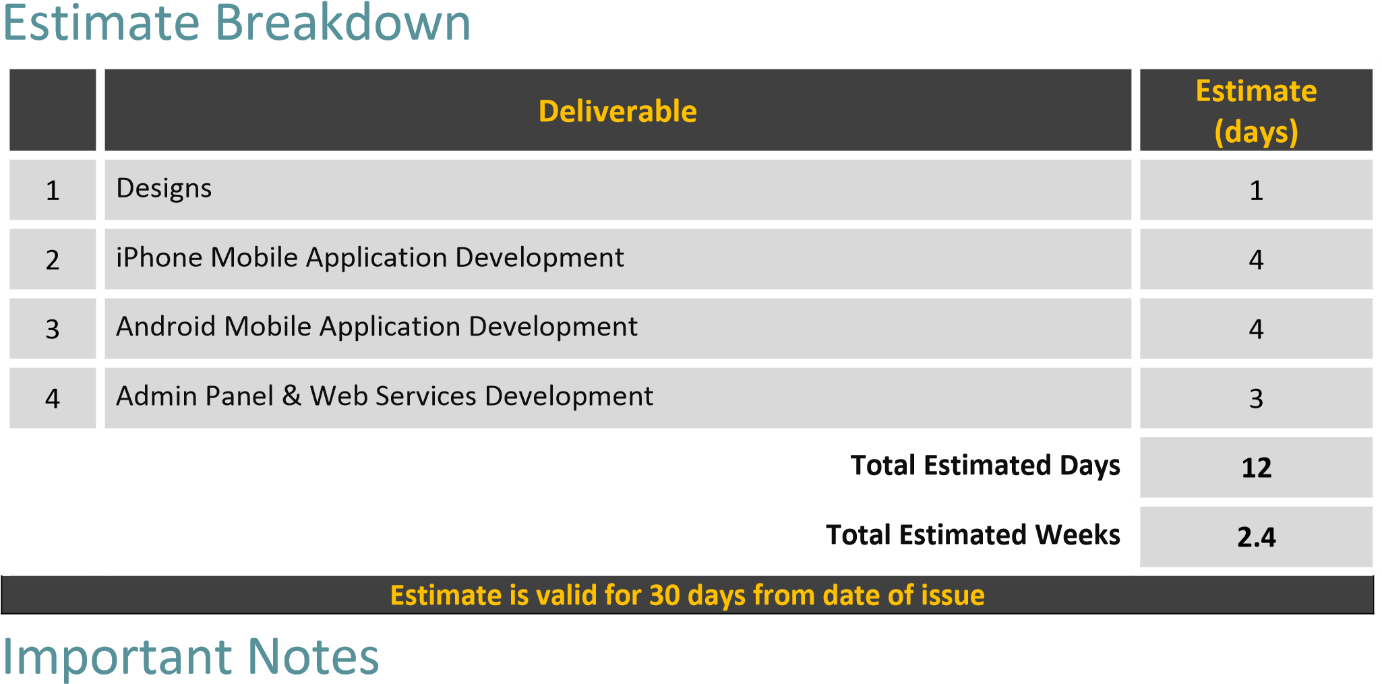

The exact speed of design & development will be affected by client turnaround times, for example responding to designs, how much feedback is given etc. Services are supplied according to our terms and conditions:

<http://www.dotsquares.com/terms>

The above estimate is based ONLY on the features which we listed in this document. If you need any other feature (NOT listed in this doc) then the Time Estimate may ramp up/down. It may also vary after sharing your response on the queries being asked in this document.

### Content Submission

(Unless otherwise mentioned in the above estimate details the following applies)

* All logos, text content, images and photography to be supplied by the client in electronic format.
* It is the client’s responsibility to enter the text and images into the site.
* Photos and graphics should be submitted in high resolution format (.jpeg /.png)

### Software & Platform Updates

This is to inform you prior that if a new version releases after providing our estimate document then it would be treated as additional activity. If you want to go forward with the Newly Released version, we would need to revise our estimate accordingly.

## Project Management Tool (DS Projects)

Dotsquares will provide free access to DSP (Dotsquares Projects) which is a project management and collaboration platform for planning, communication and tracking. It helps developers, managers and clients to stay on top of what’s happening define and manage project across teams and organizations, keeping up-todate with the schedule, work visibility and progress.

|  |  |  |
| --- | --- | --- |
|  | | |
|  | **011** | P a g e | **11** |

* Daily updates served through message posts
* Keeps digital track of conversation
* Milestones and tasks for planning
* Maintain task list for deliverables
* E-mail notifications about updates & other activities

## Deployment

Dotsquares will deploy the complete solution for the project.

* App will be uploaded to Apple App Store under your developer account (license)
* App will be uploaded to Google Play Store under your developer account (license)
* REST API will be deployed to your chosen hosting provider and connected to the database (Rest APIs act as a communication bridge between your mobile app and the central database)
* If you have any purchased any domains or if you would like to purchase, we will assist and also point your backend system to that domain

## Warranty

Your software is delivered with a free warranty of 30 days. You must notify the team during the 30 day warranty period if you identify an error in the code / system / program. Once it has been agreed Dotsquares will correct any errors made in the construction of the code / system / program at no cost. Dotsquares reserves the right to define a bug / error.

## Intellectual Property Rights

All the Intellectual Property created, written, developed, furnished or produced by us during the term of the agreement / project, that are within the scope of the agreement or any applicable Statement of Work shall be the exclusive property of the client. All the code base, assets, documentation (if any) will be handed over to you after development.

## Testing

We provide unit testing services for your project as a standard package.Unit testing is done by the team during development. We ensure all the code blocks (paths) in the software are executed at least once and produce the desired results.

We check the following:

* Graphics and user interface is as per the device resolution.
* App behaviour in absence of communication interface (2G, 3G, HSPA or WiFi).
* Battery drainage and network data consumption during continuous app usage.
* App functionality across various devices built by different manufacturers.
* App installation and first time use.
* Data sync if user changes the device.

## Environment

Dotsquares provides free of cost project hosting during the development of your mobile application / web application.

|  |  |  |
| --- | --- | --- |
|  | | |
|  | **012** | P a g e | **12** |

We upload the solution on our own web and database servers for you to test.

When the project is finished and signed off (production ready), we ask you to choose a hosting provider and deploy the project to live environment.

# Additional Services

Some additional features you might like to include can be found below, unless mentioned in the estimate above they are not currently included. Please let us know if any of these features are required:

* **EU Cookie Compliance:** This gives a viewer the option of not installing cookies, In-line with European privacy laws.
* **PCI Compliance:**This is usually required by your payment gateway supplier as part of your ecommerce merchant account agreement.
* **W3C compliance:** Why bother making your site compatible with specific browsers when you can achieve W3C compliance and make it compatible with all.
* **SEO/Digital Marketing:** Development work is done in-line with best SEO practices, but this does not include SEO optimization (keyword generation, search engine submission, analytics etc). Please see

‘additional services’ below or visit our website at: <http://digitalmarketing.dotsquares.com/>

* **Hosting:** Once development is complete you will also need a web server to host the site on. We can offer very competitive hosting services (managed and unmanaged).
* **Testing:** The work is tested by the developer during development, but this does not cover the same things as dedicated testing (unit testing, stress testing etc).
* **AAA Compliance:** Another W3C service, help users with visual disabilities to navigate and read your site.
* **Speed Testing:** Optimize the code and server for minimal load times.
* **Mail Delivery Testing:** Ensure emails always arrive by testing the mail delivery process.

|  |  |  |
| --- | --- | --- |
|  | | |
|  | **013** | P a g e | **13** |

## Support

Here at Dotsquares we have CMS monthly support and upgrade packages available to monitor your website, helping to making sure it’s secure from attacks and performing at the highest level for your visitors. Just like you, our objective is to provide overall customer satisfaction, which is why we have created these flexible support packages. Please check more information: <http://www.dotsquares.com/php-support/>

## Network Support

Network Services offered by our company are:

* Domain Registration • Server Management
* System Backup & Restore
* Emergency Support
* Network Troubleshooting and Remote Installation

## Digital Marketing

We are experts in Internet Marketing and have significant experience in the promotion of web sites. We offer our clients a range of Search Engine Optimization plans and Pay-per-Click management. We have proven successes and can help your site to get more well-targeted visitors. Why not visit our Digital Marketing site for more information: <http://digitalmarketing.dotsquares.com/>

Social media has become a platform that is easily accessible to anyone with internet access. Most of the Businesses are now available online through website and help their clients to reach them instantly. A website should be easily accessible to users that will be possible only by marketing the website that will create Brand Awareness.

Click the below Image to play the video to learn more about our Digital Marketing services and you can get the process started by completing our kick off form: <http://www.dotsquares.com/seokickoff/>

|  |  |  |
| --- | --- | --- |
|  | | |
|  | **014** | P a g e | **14** |

# Why Dotsquares

**Dotsquares are an international creative digital design and development company striving to make your vision a reality.** 

We thrive on seeing ideas grow. Since 2002, we have been working with individuals and global brands to embrace the evolving digital industry.

We have a vast amount of experience in designing, building and maintaining a wide range of web systems and mobile applications. Our scalable, first class solutions work for you with the added benefits of offshore development advantages.

We are big on trust, reliability and mutual respect so we will take the time to understand you, your product and your business. We work closely with all our clients and are always looking to forge ongoing trusted relationships – some of our clients have been with us for over a decade. We do this by providing offshore outsourcing services which reduce costs, enhance organisational flexibility and improve business and IT performance.

Our head office is in Albourne, West Sussex - near Brighton and Hove, on the sunny south coast, with an additional UK base at One Canada Square, Canary Wharf, and London. Along with offices near Washington DC, USA and Melbourne, Australia, we are planning further ones in Europe. Everything is supported by our own dedicated Development Centres in Jaipur, India.

By taking your IT project offshore you can take advantage of a rate that will not be matched by onshore competitors. This allows you to cut down on the costs whilst maintaining a quality that onshore companies struggle to match.

We take the pain out of your IT projects and let you concentrate on the business you know best: Your own.

|  |  |  |
| --- | --- | --- |
|  | | |
|  | **015** | P a g e | **15** |

## What we do…

|  |  |  |
| --- | --- | --- |
| **WEB DEVELOPMENT** | **GAMES** | **MOBILE APPS** |
| Our web development professionals bring years of  experience to meet both the business and technical  requirements of a project. We have professional teams of programmers. |  |  |
| Our game developers and artists use platforms such as  Unity, Maya, Cocos2D, Unreal,  ARKit, Creature, Puppet 2D,  Spine 2D, Maya, Max and more to create the best gaming experience. | We provide cutting-edge mobile app development, that can meet current business  needs. Apps perform efficiently  and meet the needs of mobile scalability are the ones that business demand. |
|  |  |  |
|  |  |
| **CRM SOLUTIONS** | **DIGITAL MARKETING** | **IT SUPPORT SERVICES** |
| We understand that each company is different from the  next. Here at Dotsquares, we can create bespoke CRM  systems for you to manage  your client relationships in the most efficient way. | The industry is becoming saturated by the minute and it  can be a struggle to stand out in a crowd. Using methods like SEO, SMM, PPC and Google  Ads, our marketing experts can give your brand a voice. | Whether you need server support, network  troubleshooting, remote  installation, backup and restore support, our hosting experts  are on hand 24/7 to keep your business alive. |
|  |  |  |

## Affiliations

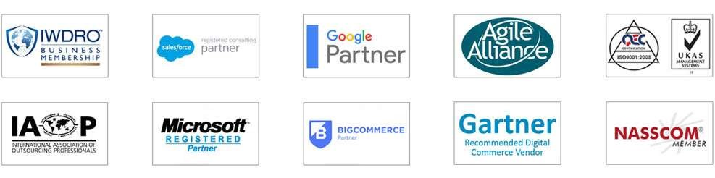

|  |  |  |
| --- | --- | --- |
|  | | |
|  | **016** | P a g e | **16** |

## Portfolio

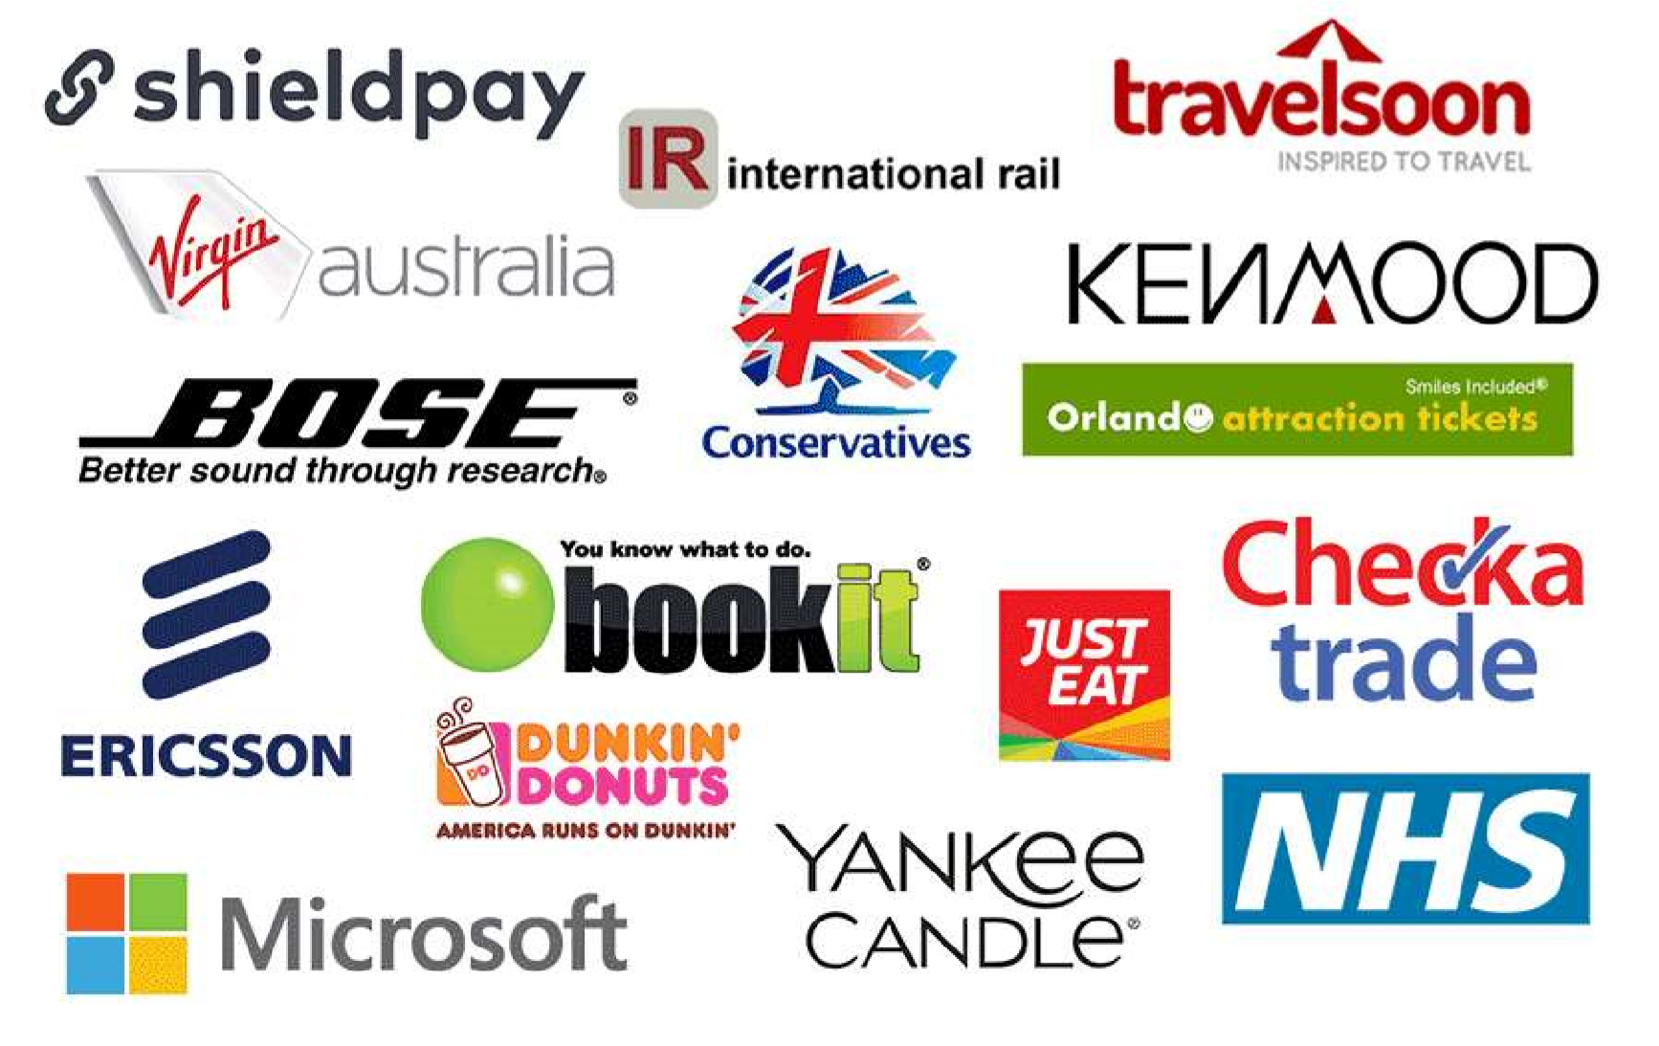

Full Portfolio: https://www.dotsquares.com/client-reviews/portfolio/

## What our clients say

*“You have been one of the best*

*“Significant cost savings can be*

*developers I have ever worked “Dotsquares went beyond the*

*made working with an*

*with. You have excellent requirements. The Team are*

*outsourced development*

*technical and interpersonal amazing and working with*

*company you can trust.*

*skills and you got my website them is a winning formula. I*

*Dotsquares have an exceptional*

*development and design feel extremely lucky to have*

*team of quality engineers who*

*project done to my amazement these gentlemen on my Team*

*work quickly and are always*

*and satisfaction!”* *with their unyielding dedication*

*aware of deadlines.”*

*to excellence.”*

**John Wussah Daniel Ox Brian Riback**

Education & Training Company Ocean Holidays Group New York Daily News

Australia UK USA

View more testimonials at: [www.dotsquares.com/client-reviews/testimonials/](http://www.dotsquares.com/client-reviews/testimonials/)